Project Design Phase
Solution Architecture
Date | 06 October 2026
Team ID | Service Now
Project Name | Centralized Medical Diagnosis Center (Diagnostic Test Center Portal)
Maximum Marks | 4 Marks
Solution Architecture:
Solution architecture bridges the gap between business problems and technology solutions. For the Centralized Medical Diagnosis Center, it describes how the ServiceNow-based Diagnostic Test Center Portal handles booking, payment, sample tracking and reports. Its goals are to:
- Find the best tech solution to solve existing business problems: manual, disconnected booking and report handling.
- Describe the structure, characteristics and behavior of the software to project stakeholders.
- Define features, development phases and solution requirements.
- Provide specifications according to which the solution is defined, managed and delivered.
Solution Architecture Diagram:
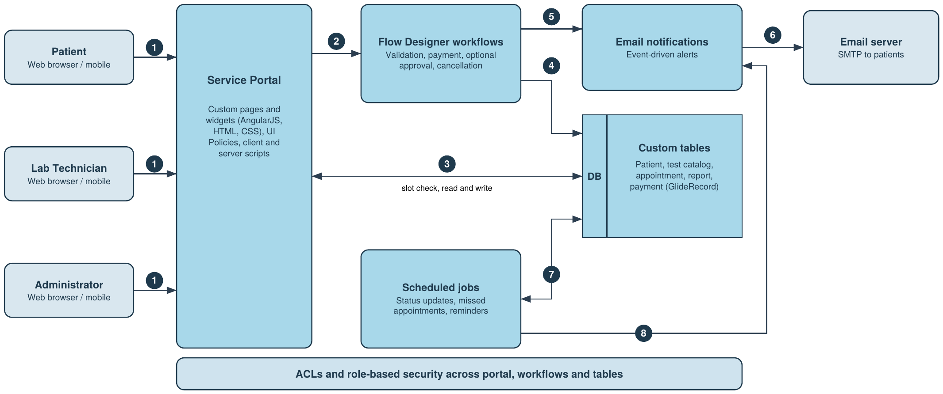
Figure 1: Architecture and data flow of the Diagnostic Test Center Portal on ServiceNow
Data flow:
- Patients, lab technicians and admins open the Service Portal in a browser; widgets and role validation show only what each role may use.
- A booking, payment, cancellation or report action starts a Flow Designer workflow for validation, payment confirmation and optional approval.
- The portal and server scripts read and write the custom tables (patient, test catalog, appointment, report, payment) with GlideRecord; slot availability is checked here to prevent overbooking.
- The workflow saves the confirmed appointment, price and payment status in the tables.
- The workflow raises events that trigger email notifications.
- Notifications go out through the email server to the patient: confirmation, receipt, report ready, cancellation.
- Scheduled jobs update appointment status (Scheduled, Sample Collected, Processing, Report Ready, Completed) and mark missed appointments.
- Scheduled jobs also trigger reminder notifications. ACLs protect every layer.
Reference: https://developer.servicenow.com/

